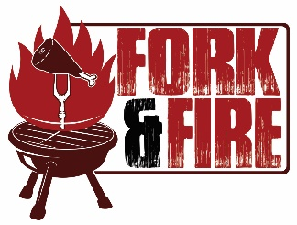

Subscribe to our Google Calendar to follow Fork & Fire Food Truck wherever we may be serving.
- Go to add calendar in your settings: calendar.google.com
- Add calendar “forkandfirefoodtruck@gmail.com”
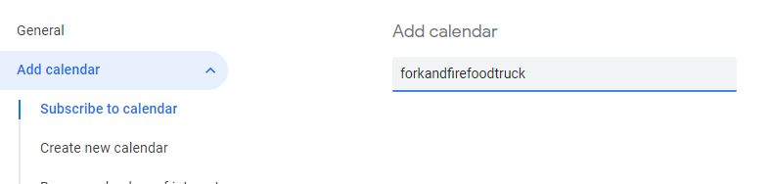
- Then set up notifications: you can set up notifications on your phone or even be emailed for each event.
